**Prepare a prediction model for predicting Price**.

**Y Predicted Plot**

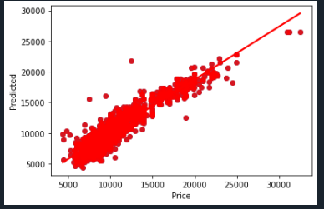

**Mean square error: 1790937.658**

**R square: 86.376**

**OLS Regression Results**

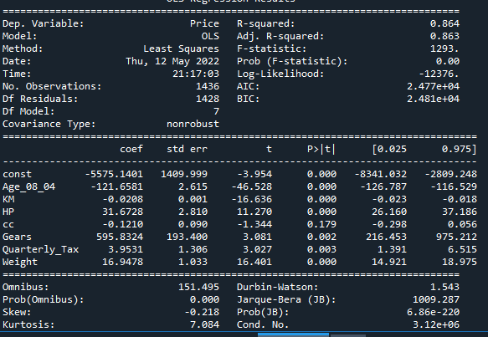

**Variance Inflation Factor**

